

**M.E.S Abasaheb Garware College**

**Pune 2023-2024**

**DEPARTMENT OF COMPUTER SCIENCE**

A PROJECT REPORT ON

“FLASH FICTION PLATFORM”

Submitted By

Mr. Nikhil Kamale (13445)

Mr. Abhishek Wavle (13443)

Mr. Sachin Karale (13446)

(TYBCA)

Under the Guidance Of

Ms. Neha Karade

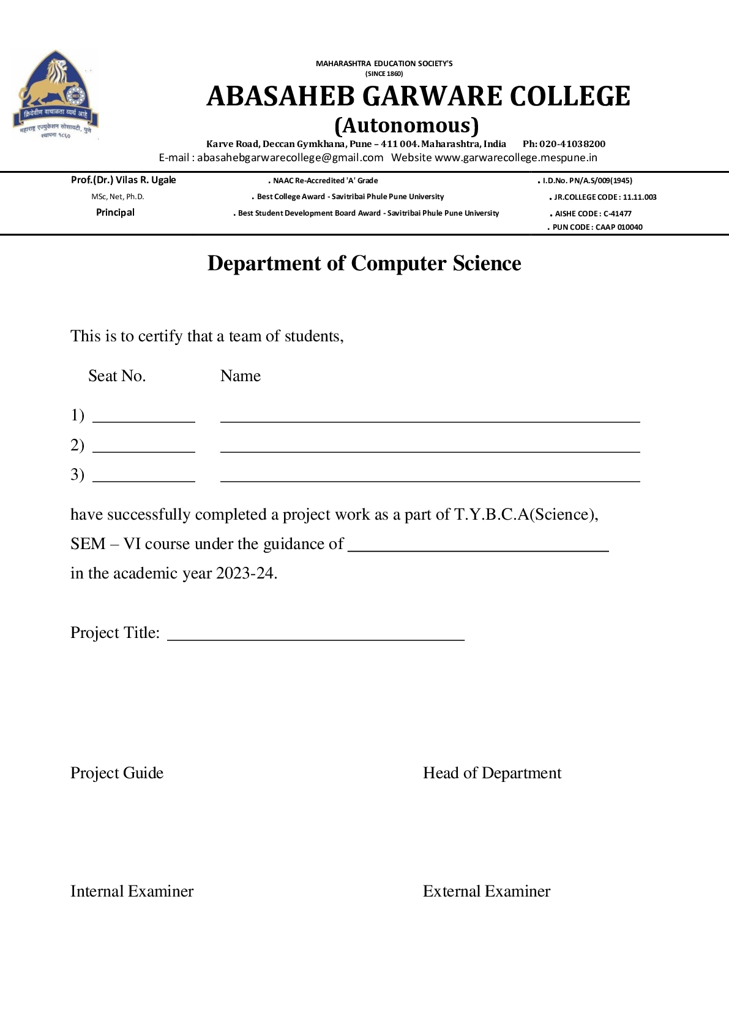

**Index**

1. Acknowledgement 3

2. Introduction 4

3. Existing System 5

4. Need for the new system 5

4. Scope of the system 7

5. Feature of the system 8

6. System Requirement 9

7. Feasibility study 10

8. Analysis and Design 11

9. Data Dictionary 17

10. Input-Output Screen 19

11. Limitations/Drawbacks 22

12. Future Enhancement 23

13. Bibliography 24

Acknowledgement

The satisfaction that accompanies that the successful completion of any task would be incomplete without the mention of people whose ceaseless co-operation made it possible, whose constant guidance and encouragement crown all efforts with success.

We are grateful to our project guide Ms. Neha Karade for the guidance, Inspiration and constructive suggestions that helpful for us in the preparation of this project.

We would like to thank our H.O.D. Prof. Chitra Nagarkar and all other Professors for We would like to thank encouraging and guiding us in our project and also for their exceptionally valuable suggestions.

Finally, we are thankful to our parents and friends for their fruitful guidance for selecting this course

Introduction

Welcome to the Flash Fiction Platform, an innovative web-based platform dedicated to the art of concise storytelling. In a world where time is precious and attention spans are short, flash fiction emerges as a captivating literary form, offering powerful narratives in a compact space. Our platform serves as a vibrant hub where writers can unleash their creativity and readers can immerse themselves in bite-sized tales that leave a lasting impact

Flash fiction, also known as micro-fiction or sudden fiction, challenges writers to distill a complete story into a limited word count, typically under 1,000 words. These brief narratives often pack a punch, delivering powerful emotions, thought-provoking themes, and unexpected twists in just a few paragraphs.

At the heart of our platform lies the concept of collaborative storytelling. While traditional storytelling is often a solitary endeavor, our platform invites users to engage in a communal experience by contributing their own endings to posted stories. This unique feature fosters interaction, sparks creativity, and allows stories to evolve in unpredictable and fascinating ways, reflecting the diverse perspectives and imaginations of our user community.

**Existing System**

Before the development of the Flash Fiction Platform, there was a lack of dedicated online spaces for writers to share and collaborate on flash fiction stories. Writers often relied on personal blogs, social media platforms, or niche forums to showcase their work, but these platforms lacked specialized features tailored to the unique needs of flash fiction enthusiasts. Readers interested in flash fiction faced challenges in discovering new stories and engaging with authors in meaningful ways

**Need for the new system: -**

The need for the Flash Fiction Platform arises from the absence of a dedicated online space for writers and readers to engage in the creation and exploration of flash fiction stories. Existing platforms lack specialized features tailored to the unique needs of flash fiction enthusiasts, such as collaborative storytelling and structured story formats.

Writers often resort to personal blogs or social media platforms to share their flash fiction, resulting in a fragmented experience for both creators and readers. There is a growing demand for a centralized platform that provides a seamless and interactive environment for publishing, discovering, and contributing to flash fiction stories.

Moreover, traditional storytelling platforms typically focus on longer-form content, overlooking the growing popularity and appeal of short-form narratives. The Flash Fiction Platform addresses this gap in the market by offering a dedicated space for writers to showcase their flash fiction and for readers to immerse themselves in captivating tales within a concise format.

**Scope of the Flash Fiction Platform:**

The Flash Fiction Platform encompasses providing a centralized online space for writers to submit their flash fiction stories and for readers to explore, read, and contribute endings to these stories. It aims to foster a vibrant community of writers and readers passionate about short-form storytelling, enabling collaborative storytelling experiences and facilitating interaction between users. Additionally, the platform seeks to address discoverability issues by offering specialized tools and features tailored to the unique needs of flash fiction enthusiasts, thereby enhancing the overall experience for both writers and readers.

**Features of the Flash Fiction Platform:**

The Flash Fiction Platform is designed to offer a range of features to support writers and readers in their exploration and creation of flash fiction stories. These features include:

**User Registration and Authentication:** Users can create accounts and securely log in to the platform.

**Story Submission:** Writers can easily submit their flash fiction stories to the platform.

**Story Reading:** Readers can explore and read posted flash fiction stories, divided into three parts.

**Alternate Endings:** Users can contribute their own endings to posted stories, fostering collaborative storytelling.

**User Profiles:** Each user has a profile where they can view their submitted stories and contributions.

**SYSTEM REQUIREMENT**

**Hardware Requirements:**

**Computers:** You'll need a computer for building and running the system. Any standard desktop or laptop will do for development.

**Smartphones/Tablets:** Since your system will be accessible on mobile devices, having a smartphone or tablet for testing is essential.

**Internet Connection:** A stable internet connection is needed for accessing and sharing data within the system.

**Software Requirements:**

**Operating System:** Your computer should have an operating system like Windows, Linux, etc.

**Development Tools:** You’ll need software for writing code, like a text editor (e.g., Visual Studio Code) and a browser for testing.

**Programming Languages:** Languages like JavaScript, HTML, CSS, and possibly Python for the backend are what you’ll use to build the system.

**Database Software:** You’ll need software like SQLite to store and manage the data collected by the system.

**FEASIBILITY STUDY: -**

**1. Technical Feasibility:**

**Assessment:** The technical infrastructure required for the platform, including server setup, database management, and web application development, was evaluated.

**Conclusion:** The project is technically feasible with available resources and expertise.

**2. Economic Feasibility:**

**Assessment:** The costs associated with developing, deploying, and maintaining the platform were estimated. This includes expenses related to software development, server hosting, domain registration, and ongoing maintenance.

**Conclusion:** The economic feasibility analysis indicated that the project is financially viable within the allocated budget.

**3. Operational Feasibility:**

**Assessment:** The operational aspects of managing and maintaining the platform were considered. This includes user registration, content moderation, customer support, and scalability to accommodate growing user base and content.

**Conclusion:** The platform's operational requirements can be effectively managed with proper planning and implementation of administrative tools and procedures.

**Analysis and Design**

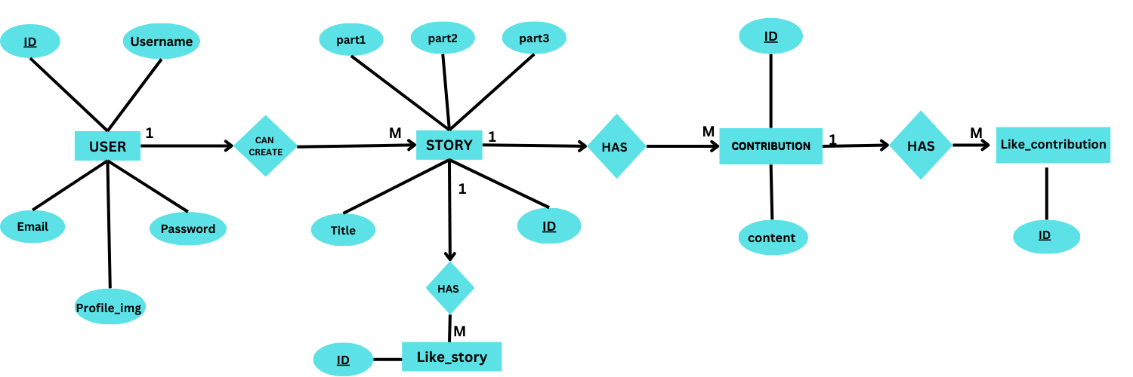

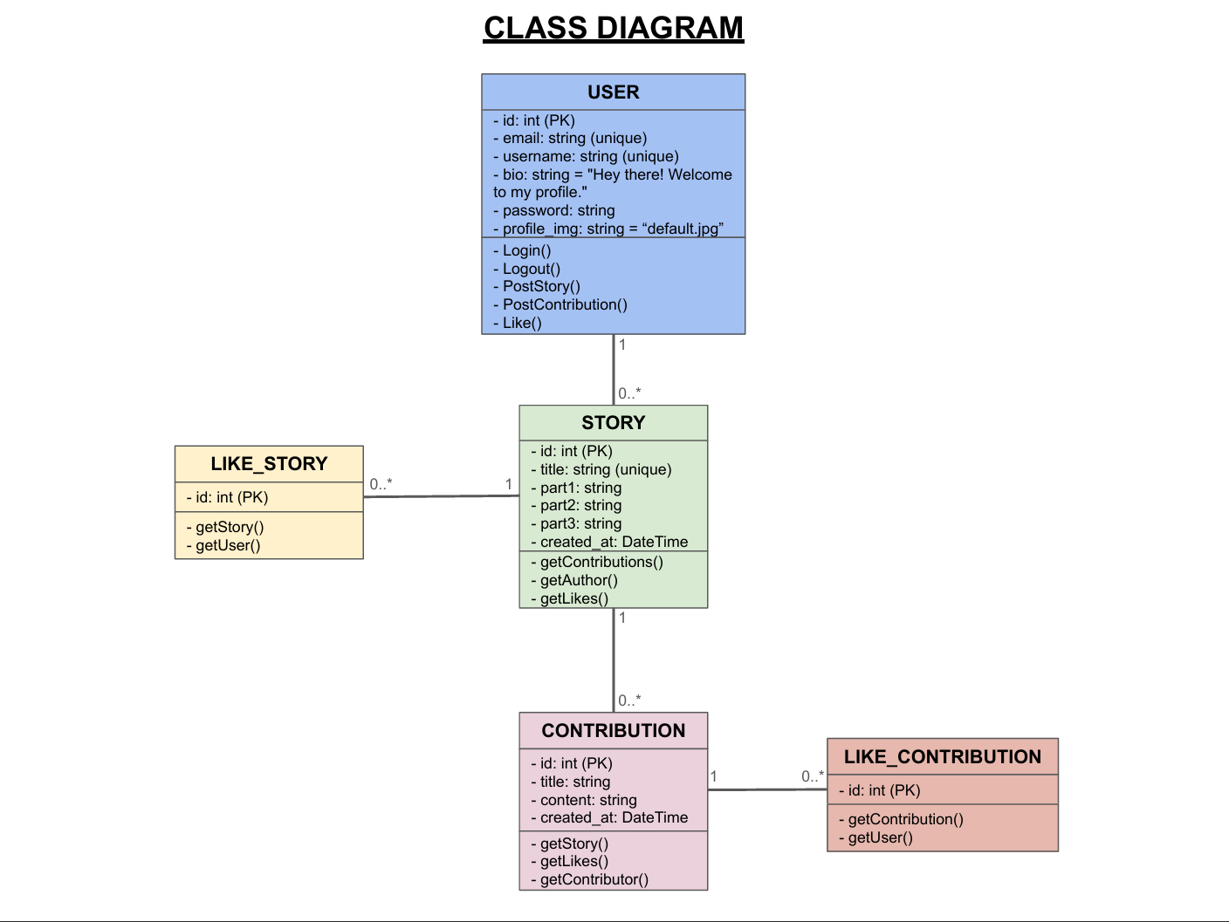

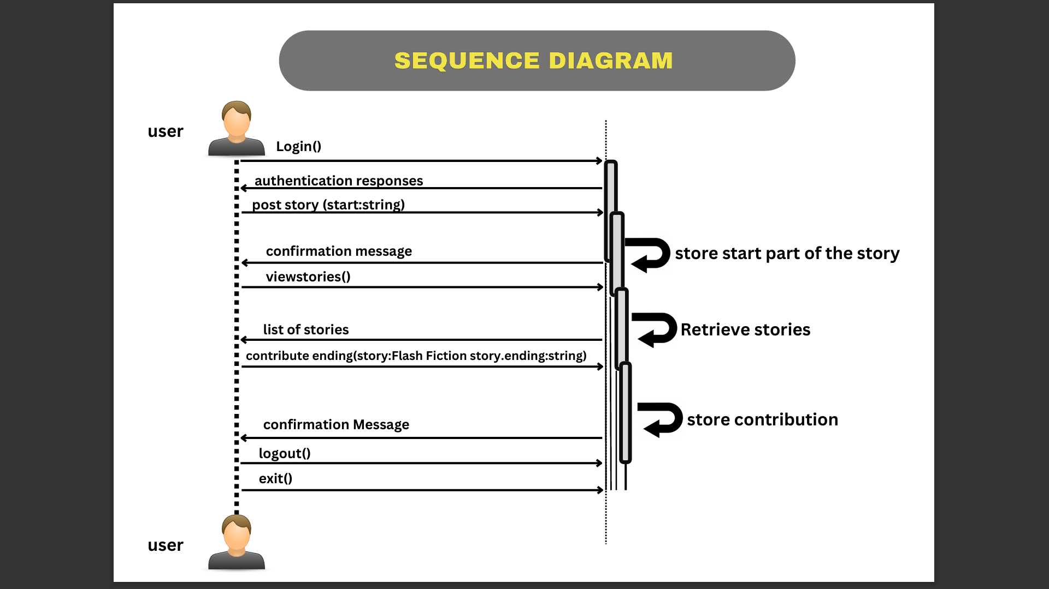

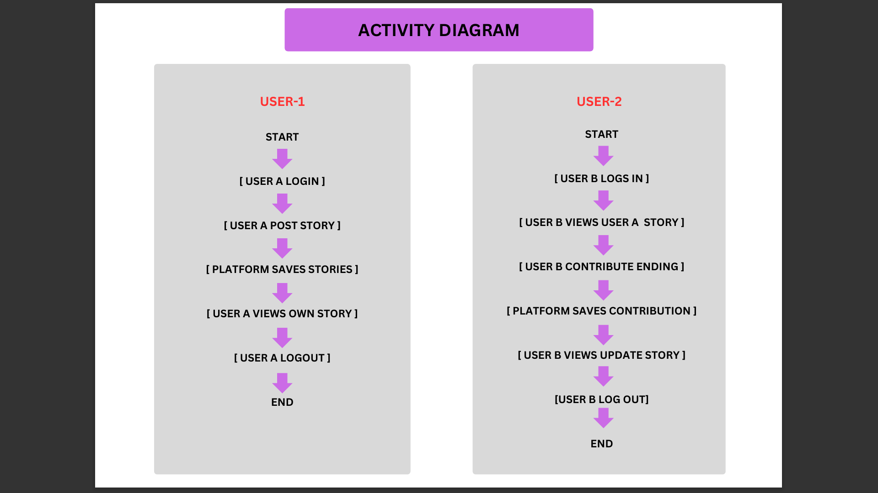

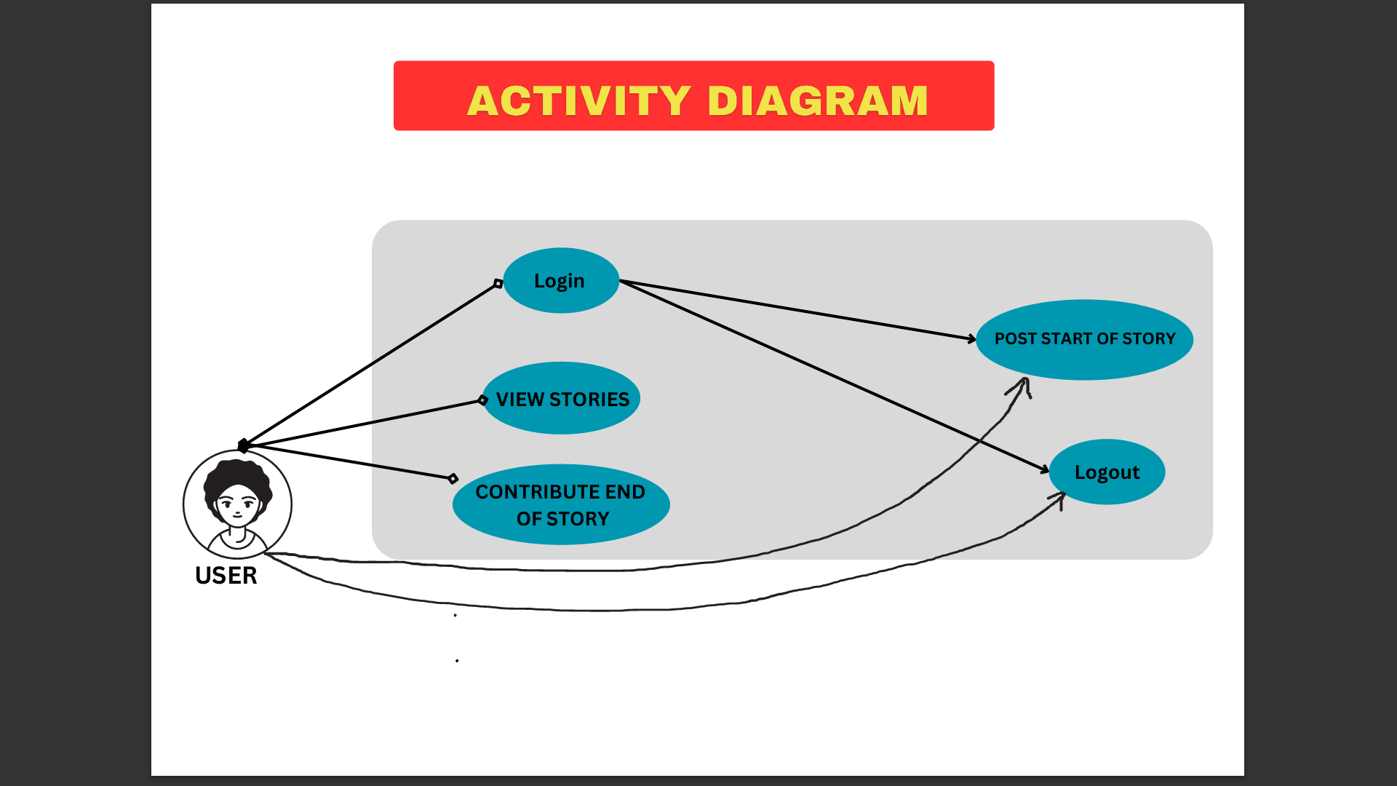

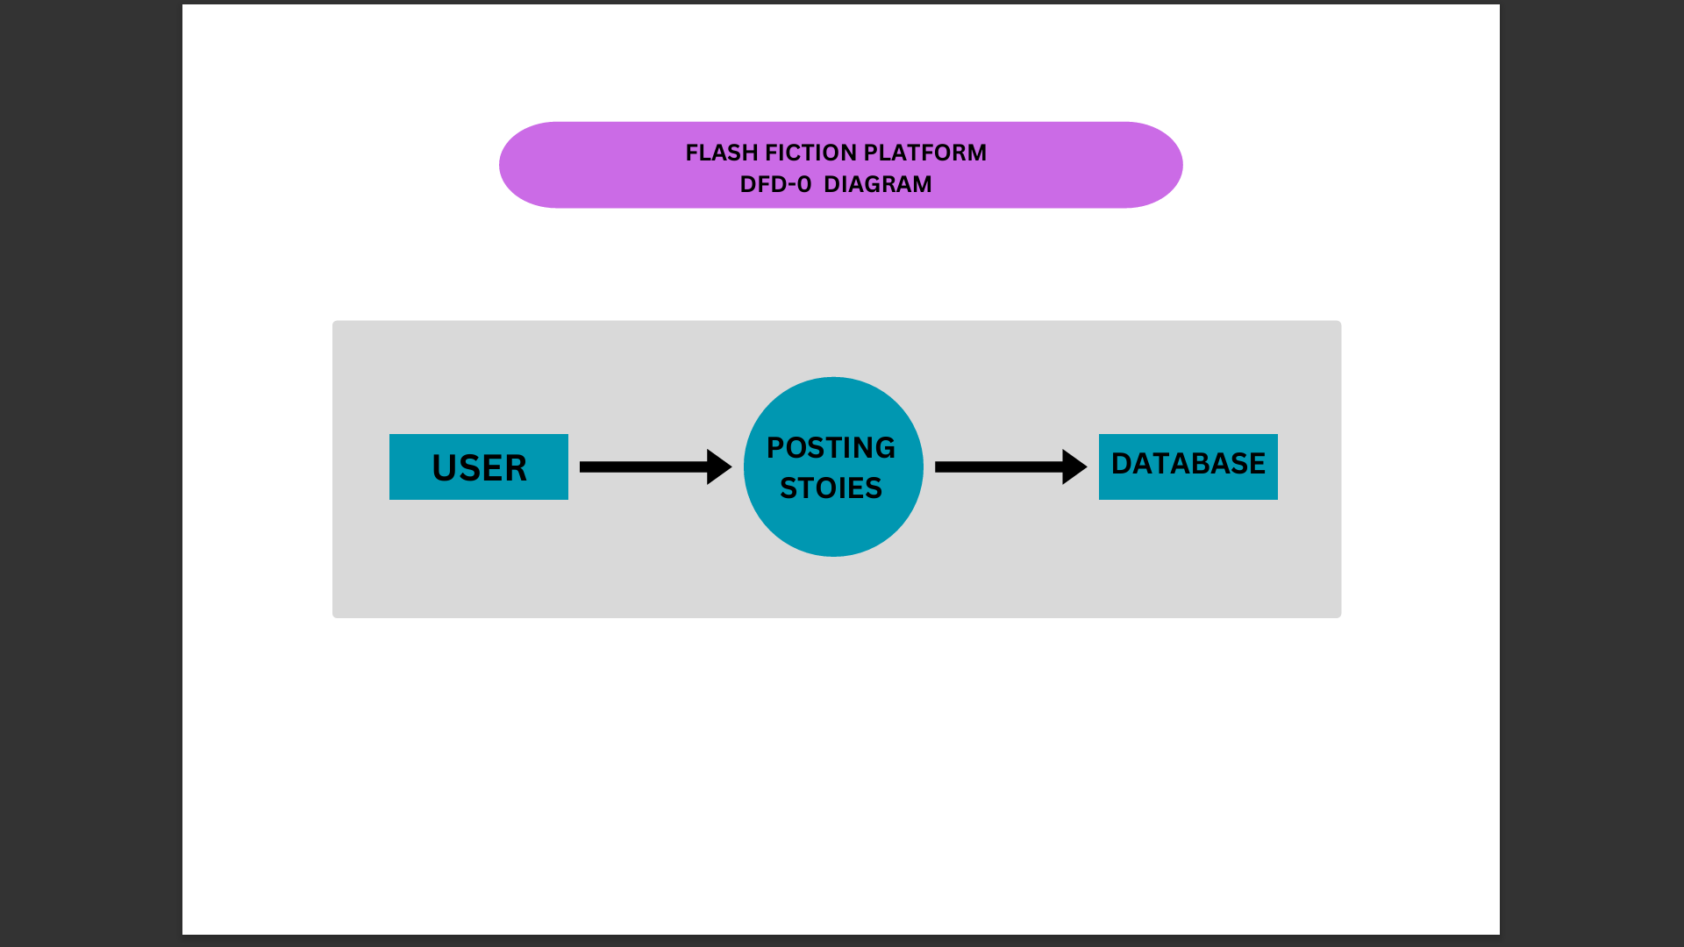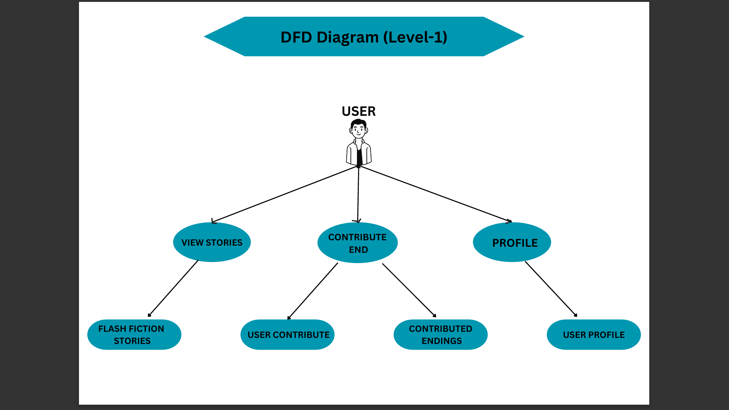

**Data Dictionary**

**User Table**

|  |  |  |  |
| --- | --- | --- | --- |
| Sr.no | Attribute | Data Type | Constraints |
| 1 | Id | Integer | Not Null |
| 2 | Email | Varchar(150) | Not Null |
| 3 | Username | Varchar(50) | Not Null |
| 4 | Bio | Varchar(250) | Not Null |
| 5 | Password | Varchar(150) | Not Null |

**Story Table**

|  |  |  |  |
| --- | --- | --- | --- |
| Sr.no | Attribute | Data Type | Constraints |
| 1 | Id | Integer | Not Null |
| 2 | Title | Varchar(50) | Not Null |
| 3 | Part1 | Varchar(500) | Not Null |
| 4 | Part2 | Varchar(500) | Not Null |
| 5 | Part3 | Varchar(500) | Not Null |
| 6 | Created_at | DateTime | Not Null |
| 7 | User_id | Integer | Not Null |

**Contribution Table**

|  |  |  |  |
| --- | --- | --- | --- |
| Sr.no | Attribute | Data Type | Constraints |
| 1 | Id | Integer | Not Null |
| 2 | Title | Varchar(50) | Not Null |
| 3 | Content | Varchar(50) | Not Null |
| 4 | Created_at | DateTime | Not Null |
| 5 | User_id | Integer | Not Null |
| 6 | Story_id | Integer | Not Null |

**Like_Contribution Table**

|  |  |  |  |
| --- | --- | --- | --- |
| Sr.no | Attribute | Data Type | Constraints |
| 1 | Id | Integer | Not Null |
| 2 | User_id | Integer | Not Null |
| 3 | Contribution_id | Integer | Not Null |

**Like_Story Table**

|  |  |  |  |
| --- | --- | --- | --- |
| Sr.no | Attribute | Data Type | Constraints |
| 1 | Id | Integer | Not Null |
| 2 | User_id | Integer | Not Null |
| 3 | Story_id | Integer | Not Null |

**Input-Output Screen**

**Limitations / Drawbacks**

**Limited Story Length:** Due to the nature of flash fiction, stories submitted to the platform are constrained by a maximum word count, which may limit the depth and complexity of narratives.

**Quality Control:** Ensuring the quality of user-generated content, including stories and endings, may be challenging. There is a risk of low-quality or inappropriate submissions that could detract from the overall user experience.

**Dependency on User Engagement:** The success of the platform relies heavily on user engagement and contributions. If users are not actively submitting stories, contributing endings, or interacting with each other, the platform may struggle to maintain momentum and relevance.

**Content Ownership and Rights:** Clarifying ownership and rights management for user-submitted content, particularly in collaborative storytelling scenarios, can be complex and may require clear terms of service and copyright policies.

**Future Enhancement**

One area of focus is enhancing collaborative storytelling features, such as implementing real-time collaboration tools for users to co-write stories together. This could involve integrating collaborative editing functionalities, allowing multiple users to contribute to a story simultaneously, fostering dynamic and interactive storytelling experiences. The platform plans to introduce advanced analytics and recommendation systems to personalize content discovery for users. By analyzing user preferences, reading habits, and engagement patterns, the platform can provide tailored recommendations for stories and endings, enhancing user satisfaction and retention. Integration with social media platforms and enhanced sharing features will enable users to easily promote their stories and engage with a wider audience. Implementing social sharing buttons, story embedding options, and seamless integration with popular social networks will facilitate user-driven promotion and community building.

**Bibliography**

1. GitHub: https://github.com/nklxsns/flash-fiction
2. Stack Overflow: <https://stackoverflow.com/>
3. YouTube:

<https://www.youtube.com/@OnlineTutorialsYT>

<https://www.youtube.com/@ApnaCollegeOfficial>

1. W3Schools: <https://www.w3schools.com/python/default.asp>